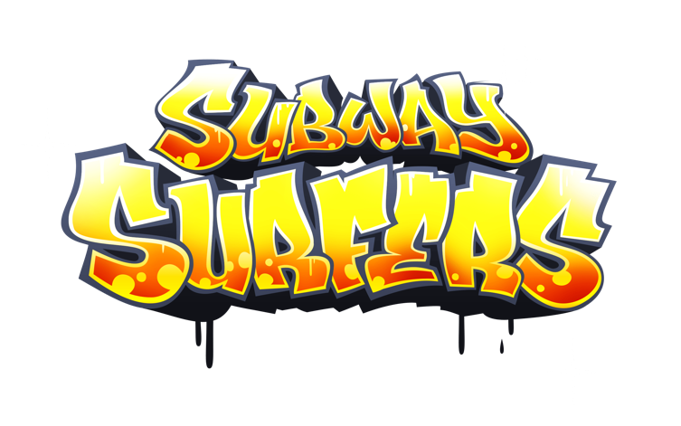

This is an endless runner game developed by Kiloo using Unity. The main goal of this game is trying to escape the capture from the Inspector of the train station running down the tracks. During the game is possible to collect money and find some powerups. My model of this game on Machinations is:

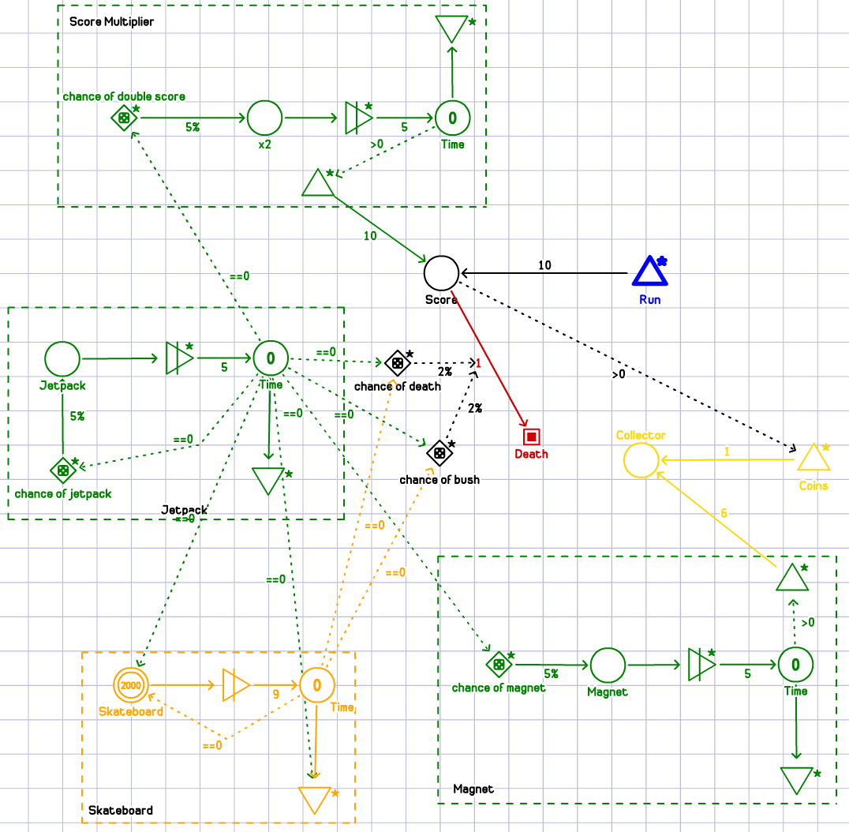

**Game progress model**

During the game you have to complete some missions to obtain a higher multiplier for your score, but it’s not necessary.

**Game economy model**

In the game there two types of collectable resources: coins and keys. Coins are very common during the game and are used to buy new characters, enhance powerups and buy other stuff like skateboards and skateboard skins. Keys are pretty rare and are used mostly to add new powerups to your skateboard, but also used to revive your character whenever you have been caught.

**Game level design**

This game has no levels, but, as aforementioned, you can improve your score multiplier completing some quests. For each single multiplier score (from 1 to 30) you have to complete 3 quests, few examples are “Collect exactly 500 coins in one run” or “Pick up 5 Magnet in one run” and so on. When you reach 30 you can still continue to complete quests, but you can’t increase your multiplier. From now on every 3 quests completed you receive a Mystery Box.

**Game randomization model**

In this game there are two random things, the first is when and where powerups appear on the map and the second is the content of the Mystery Box.

From my personal experience I can say that when you have to find a specific powerup to complete your mission, it appears rarely. Moreover, if your next mission (unseen) is for example “Pick up 3 Score Multiplier” they will appear very often and then when the mission is active they disappear.